Computational Mathematics
Linear Interpolation
Linear interpolation:
The simplest form of interpolation is to approximate two data points by a straight line. Suppose we are given two points$\left(x_{1},f\left(x_{1}\right)\right) and \left(x_{2},f\left(x_{2}\right)\right)$. These two points can be connected linearly as shown fig. below: using the concept of similar triangles, we show that:
$$\frac{f\left(x\right)-f\left(x_{1}\right)}{x-x_{1}}=\frac{f\left(x_{2}\right)-f\left(x_{1}\right)}{x_{2}-x_{1}}…………………(1)$$
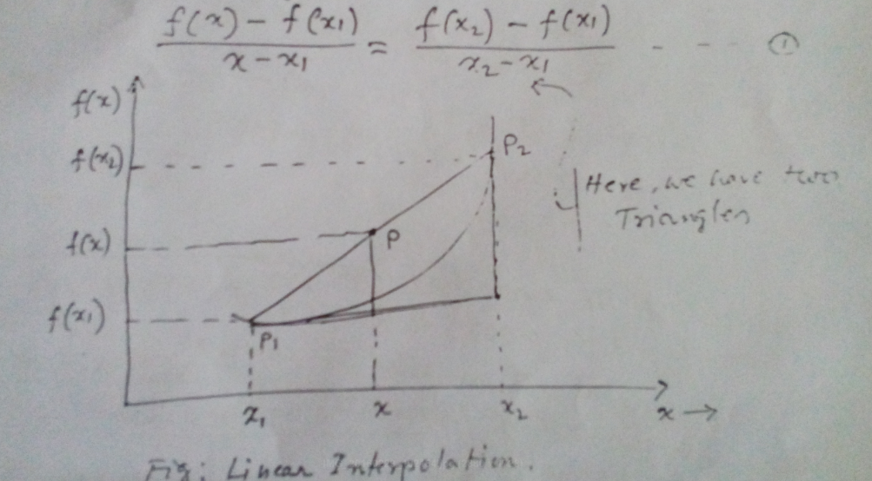
Fig: Linear Interpolation
From (1) we get: $f\left(x\right)=f\left(x_{1}\right)+\frac{\left(x-x_{1}\right)\left(f\left(x_{2}\right)-f\left(x_{1}\right)\right)}{x_{2}-x_{1}}…………\left(2\right)$
Which is known as Linear Interpolation formula.
Ex-1: The table below gives square roots for integers.
x | 1 | 2 | 2.5 | 3 | 4 | 5
f(x) | 1 | 1.4142 | 1.5811 | 1.7321 | 2 | 2.2361

Solution:
The given value of 2.5 lies between the points 2 and 3. Therefore:
$$x_{1}=2:f\left(x_{1}\right)=1.4142$$
$$x_{2}=3:f\left(x_{2}\right)=1.7321$$
Then by the help of linear interpolation formula (2) get:
$$f\left(2.5\right)=1.4142+\frac{\left(2.5-2.0\right)\left(1.7321-1.4142\right)}{3.0-2.0}=1.5732$$
$$[Error=1.5811-1.5732=0.0079]$$
The correct answer is 1.5811$\left[\sqrt{2.5}=1.5811\right]$.
The difference is due to the use of a linear model to an interpolation.
Cheek the results to in different interval:
Say $x_{1}=2 and x_{2}=4$ though we know $\sqrt{2.5}$ must lies between 2 and 3.
$$∴f\left(x_{1}\right)=1.4142; f\left(x_{2}\right)=2$$
Then by (2) we can write:
$$f\left(2.5\right)=1.4142+\left(2.5-2.0\right)\frac{(2.0-1.4142)}{4.0-2.0}=1.5607$$
Error: 1.5811-1.5607=0.0204
Notice that the error has increased from before i.e. 0.0079 to 0.0204
Integral, the smaller the interval between the interpolating data points. The better will be the approximation.

Ex-2: Table below gives values of square of integers:
x | 1 | 2 | 3 | 3.25 | 4 | 5
$$x^{2}$$ | 1 | 4 | 9 | 10.5625 | 16 | 25

Using the linear interpolation formula estimate the square root of 3.25
- Using the points 3 and 4
- Using the points 2 and 4
[Compare and comment on the results.]
Ex-3: Find the linear interpolation polynomial for each of the following pairs of points:
- (0,1) and (1,3)
- (-2,3) and (7,12)
[Matlab]
Other polynomial Form/Interpolation
- Power Form:
$$p\left(x\right)=a_{0}+a_{1}x+a_{2}x^{2}+……….+a_{n}x^{n}⇒p\left(x\right)=a_{0}+a_{1}x[power=1]$$
- Shifted Form:
$$p\left(x\right)=a_{0}+a_{1}(x-c)+a_{2}{\left(x-c\right)}^{2}+……….+a_{n}{\left(x-c\right)}^{n}[known as taylor expansion/series]$$
- Newton Form:
$$p\left(x\right)=a_{0}+a_{1}\left(x-c_{1}\right)+a_{2}\left(x-c_{1}\right)\left(x-c_{1}\right)+…….+a_{n}\left(x-c_{1}\right)\left(x-c_{2}\right)……(x-c_{n})$$
- Linear Interpolation:
$$f\left(x\right)=f\left(x_{1}\right)+f\left(x-x_{1}\right)\frac{f\left(x_{2}\right)-f\left(x_{1}\right)}{x_{2}-x_{1}}$$
- Newton-Gregory:
(5.1) Forward Interpolation with equal intervals:
$$y\left(x\right)=y_{0}+u∆y_{0}+\frac{u\left(u-1\right)}{2!}∆^{2}y_{0}+………+\frac{u\left(u-1\right)\left(u-2\right)…..\left(u-n+1\right)}{n!}∆^{n}y_{n}$$
Useful for interpolating the values of f(x) near the beginning of the set of given values.
(5.2) Backward Interpolation with equal interval:
$$y\left(x\right)=y_{n}+u∇y_{n}+\frac{u\left(u+1\right)}{2!}∇^{2}y_{n}+\frac{u\left(u+1\right)(u+2)}{3!}∇^{3}y_{n}+…………+\frac{u\left(u+1\right)\left(u+2\right)………\left(u+n-1\right)}{n!}∇^{n}y_{n}$$
Where $y_{0}, y_{1}, y_{2},……………y_{n}$ are the values of y for the (n+1) equidistant values of $x_{0}, x_{1}, x_{2},…………x_{n}.$
- Divided Difference:
Let the arguments/points $x_{0}, x_{1}, x_{2}, ……..x_{n}$ to the correspond values of $f\left(x_{0}\right), f\left(x_{1}\right), f\left(x_{2}\right),…………f\left(x_{n}\right)$of the polynomial f(x); not necessarily equal spaced. Then the generalized formula for:
(6.1) First divided difference:
$$f\left(x_{i}, x_{i+1}\right)=\frac{f\left(x_{i+1}\right)-f\left(x_{i}\right)}{x_{i+1}-x_{i}} ;where i=0,1,2,……4$$
Then $f\left(x_{0}, { x}_{1}\right)=\frac{f\left(x_{1}\right)-f\left(x_{0}\right)}{x_{1}-x_{0}}$
$$f\left(x_{1}, x_{2}\right)=\frac{f\left(x_{2}\right)-f\left(x_{3}\right)}{x_{2}-x_{1}}$$
………………………………………….
………………………………………….
$$f\left(x_{n-1}, x_{n}\right)=\frac{f\left(x_{n}\right)-f\left(x_{n-1}\right)}{x_{n}-x_{n-1}}$$
(6.2) Second divided difference:
$$f\left(x_{i}, x_{i+1}, x_{i+2}\right)=\frac{f\left(x_{i+1}, x_{i+2}\right)-f\left(x_{i} , x_{i+1}\right)}{x_{i+2}-x_{i}} \left[i=0,1,2,……….\right]$$
Then, $f\left(x_{0}, x_{1},x_{2}\right)=\frac{f\left(x_{1},x_{2}\right)-f\left(x_{0},x_{1}\right)}{x_{2}-x_{0}}$
(6.3) Nth Divided Difference:
$$f\left(x_{0},x_{1},………..x_{n}\right)=\frac{f\left(x_{1},x_{2},………x_{n}\right)-f\left(x_{0},x_{1},……..x_{n-1}\right)}{x_{n}-x_{0}}$$
- Newton Divided Difference Formula for unequal interval:
$$f\left(x\right)=f\left(x_{0}\right)+\left(x-x_{0}\right)f\left(x_{0},x_{1}\right)+\left(x-x_{0}\right)\left(x-x_{1}\right)f\left(x_{0},x_{1},x_{2}\right)+………….+\left(x-x_{0}\right)\left(x-x_{1}\right)…..\left(x-x_{n-1}\right)f\left(x_{0},x_{1},x_{2}…….x_{n}\right)$$
- Lagrange’s Interpolation formula for unequal Intervals:
$$f\left(x\right)=\frac{\left(x-x_{1}\right)\left(x-x_{2}\right)………\left(x-x_{n}\right)}{\left(x_{0}-x_{1}\right)\left(x_{0}-x_{2}\right)………\left(x_{0}-x_{n}\right)}f\left(x_{0}\right)+\frac{\left(x- x_{0}\right)\left(x - x_{2}\right)…..\left(x - x_{n}\right)}{{(x}_{1}-x_{0})(x_{1}-x_{2})………(x_{1}-x_{n})}f\left(x_{1}\right)+\frac{\left(x- x_{0}\right)\left(x - x_{1}\right)\left(x-x_{3}\right)…..\left(x - x_{n}\right)}{{(x}_{2}-x_{0})(x_{2}-x_{1})(x_{2}-x_{3})………(x_{2}-x_{n})}f\left(x_{2}\right)+……………..+\frac{\left(x- x_{0}\right)\left(x - x_{1}\right)(x-x_{2})…..\left(x - x_{n-1}\right)}{{(x}_{n}-x_{0})(x_{n}-x_{1})(x_{n}-x_{2})………(x_{2}-x_{n-1})}f\left(x_{n}\right)$$
Ex-1: Newton’s Forward and Backward (both):
Find the value of y at x=21 and x=28 from the following data:
X= | 20 | 23 | 26 | 29
Y= | 0.342 | 0.3907 | 0.4384 | 0.4848

Solution: First we construct the difference table for the given data as follows
X | y | y | y | y
20 | 0.342
 |  | 0.0487
23 | 0.3907 |  | -0.0010
 |  | 0.0477 |  | -0.0003
26 | 0.4384 |  | -0.0013
 |  | 0.0464
29 | 0.4848

- We have to find y(21):
Here, $u=\frac{x-x_{0}}{h}=\frac{21-20}{3}=0.3333$
Since x=21 is nearer to the beginning of the table. So, we use Newton’s forward interpolation.
i.e. $y\left(x\right)=y_{0}+u∆y_{0}+\frac{u\left(u-1\right)}{2!}∆^{2}y_{0}+\frac{u\left(u-1\right)\left(u-2\right)}{3!}∆^{3}y_{0}$
$$∴y\left(21\right)=0.342+0.3333\left(0.0487\right)+\frac{0.3333\left(0.3333-1\right)}{2!}\left(0.0010\right)+\frac{0.3333\left(0.3333-1\right)\left(0.3333-2\right)}{3!}\left(-0.0003\right)=0.3583$$
- Again we have to find y(28):
Since, x=28 is nearer to end value. So, we use Newton’s Backward Interpolation formula. Here $u=\frac{x-x_{n}}{h}=\frac{28-29}{3}=-0.3333$
$$∴y\left(x\right)=y_{n}+u∇y_{n}+\frac{u\left(u+1\right)}{2!}∇^{2}y_{n}+\frac{u\left(u+1\right)(u+2)}{3!}∇^{3}y_{n}$$
$$⇒y\left(28\right)=0.4848+\left(-0.3333\right)\left(0.0464\right)+\frac{\left(-0.3333\right)\left(-0.3333+1\right)}{2!}\left(-0.0013\right)+\frac{\left(-0.3333\right)\left(-0.3333+1\right)\left(-0.3333+2\right)}{3!}\left(-0.0003\right)=0.46946$$
Therefore the value of y at x=21 and x=28 are 0.3583 and 0.46946 respectively. (Ans.)

Ex-2: The population of a town in the decimal census was as given below. Estimate the population for the year 1895.
Year (x) | 1891 | 1901 | 1911 | 1921 | 1931
Population (y) | 46 | 66 | 81 | 93 | 101

Solution: Construct the difference table. We have to find y(1895). Since x=1895 is near to the beginning of the table/data. So, we use Newton’s forward interpolation formula.
Here, $u=\frac{x-x_{0}}{h}=\frac{1995-1891}{10}=0.4$

Ex-3: The following table gives the population of a town during the last six censuses. Estimate using any suitable interpolation formula, the increase in the population during the period from year 1996 to 1998.
Year (x) | 1961 | 1971 | 1981 | 1991 | 2001 | 2011
Population (th) | 12 | 15 | 20 | 27 | 39 | 52

Solution: Construct the difference table. Use Newton’s backward interpolation formula.
Here, $\left(i\right) u=\frac{x-x_{n}}{h}=\frac{1996-2011}{10}=-1.5⇾for 1996$
Then, $\left(ii\right) u=\frac{x-x_{n}}{h}=\frac{1998-2011}{10}=-1.3⇾for 1998$

Ex-4: Find the annual premium at the age of 46 and 63 from the following table:
Age (x) | 45 | 50 | 55 | 60 | 65
Premium (y) | 114.84 | 96.16 | 83.32 | 74.48 | 68.48

- Forward ⇾ $u=\frac{x-x_{0}}{h}=\frac{46-45}{5}=0.2$
- Backward ⇾$u=\frac{x-x_{n}}{h}=\frac{63-65}{5}=-0.4$
Ex-5: Marks obtained by the students in an examination are given below:
Marks (x) | 45 | 50 | 55 | 60 | 65
No of students (y) | 114.84 | 96.16 | 83.32 | 74.48 | 68.48
Estimate the number of students who obtained less than
- 42 marks
- 70 marks
Solution: First we prepare the cumulative frequency table as below:
Marks Obtained | No of students
<20 | 41
<40 | 41+62=103
<60 | 103+65=168
<80 | 168+50=228
<100 | 218+17=235

Difference table:
Marks (x) | y | y | y | y | $∆^{4}$y
20 | 41
 |  | 62
40 | 103 |  | 3
 |  | 65 |  | -18
60 | 168 |  | -15 |  | 0
 |  | 50 |  | -18
80 | 218 |  | -33
 |  | 17
100 | 235

- For 42:
Here, $u=\frac{x-x_{0}}{h}=\frac{42-20}{20}=1.1$
We use Newton’s forward interpolation.
i.e. $y\left(x\right)=y_{0}+u∆y_{0}+\frac{u\left(u-1\right)}{2!}∆^{2}y_{0}+\frac{u\left(u-1\right)\left(u-2\right)}{3!}∆^{3}y_{0}=110$
The number of students who obtained less than 42 marks=110 (Ans.)

- For 70:
We use Newton’s Backward Interpolation formula. Here $u=\frac{x-x_{n}}{h}=\frac{70-100}{20}=-1.5$
$$∴y\left(x\right)=y_{n}+u∇y_{n}+\frac{u\left(u+1\right)}{2!}∇^{2}y_{n}+\frac{u\left(u+1\right)(u+2)}{3!}∇^{3}y_{n}=196$$
The number of students who obtained less than 70 marks =196 (Ans.)
Ex-6: Marks obtained by the students in an examination are given below:
Marks (x) | 30-40 | 40-50 | 50-60 | 60-70 | 70-80
No of students (y) | 31 | 42 | 51 | 35 | 31
Estimate the number of students who obtained:
- Less than 45 marks
- Greater than 45 marks
- Between 40 and 45 marks
Ex-7: Find the polynomial f(x) passes through the points: $\left(0,1\right), \left(1,3\right), \left(2,7\right) and \left(3,13\right).$
Solution: we construct the difference table for the given data is as below:
X | y | y | y | y
0 | 1
 |  | 2
1 | 3 |  | 2
 |  | 4 |  | 0
2 | 7 |  | 2
 |  | 6
3 | 13

Here, $u=\frac{x-x_{0}}{h}=\frac{x-0}{1}=x$
So, by Newton’s forward interpolation formula: we get:
$$f\left(x\right)=y_{0}+u∆y_{0}+\frac{u\left(u-1\right)}{2!}∆^{2}y_{0}=1+x\left(2\right)+\frac{x\left(x-1\right)}{2}.2=1+2x+x^{2}-x$$
$$⇒f\left(x\right)=x^{2}+x+1⇾which is the required polynomial of second degree.$$
Ex-8: Using the following table find the Function f(x):
X: | 0 | 1 | 2 | 3 | 4
f(x): | 3 | 6 | 11 | 18 | 27

